H.T No
Regulations:
A18

Sreenidhi Institute of Science and Technology
(An Autonomous Institution)
Code No: 7BC02 Date: 15-Dec-2020 (FN)

B.Tech I-Year II-Semester External Examination, Nov/Dec - 2020 (Regular & Supplementary)
ENGINEERING GRAPHICS AND DESIGN (CIVIL, CSE, IT and ECM)

Time: 2 Hours Max.Marks:70

Note: a) No additional answer sheets will be provided.
b) All sub-parts of a question must be answered at one place only, otherwise it will not be valued.
c) Missing data can be assumed suitably.

ANSWER ANY 5 OUT OF 8 QUESTIONS. EACH QUESTION CARRIES 14 MARKS.

1. |  | Construct a parabola, when the distance between focus and the directrix is 50mm.Draw the tangent and normal at any point P on the curve. | [14M]
2. |  | A line AB of 80mm length, is inclined at an angle 30° to H.P and 45° to V.P .The point A is 20mm above H.P and 25mm in front V.P. draw the projections of the line. | [14M]
3. |  | Draw the projections of a cylinder of 40mm diameter and axis 65mm long ,when it is lying on H.P, with its axis inclined at 45° to H.P and parallel to V.P. | [14M]
4. |  | A cylinder of diameter of base 35mm and axis 65mm long ,is resting on its base on H.P .It is cut by a section plane ,perpendicular to V.P. and inclined at 45° to H.P . The section plane is passing through the top end of an extreme generator of the cylinder. Draw the development of the lateral surface of the cut cylinder.ϕ | [14M]
5. |  | Draw the orthographic view of below figure  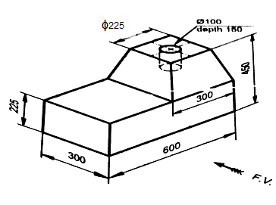 | [14M]
6. | a) | Define CAD. Explain its advantages and applications. | [7M]
 | b) | Differentiate between 2D and 3D. | [7M]
7. |  | A Circle of 50mm diameter, rolls along a line for one revolution clock wise direction. Draw the locus of a point on the circle, which is contact with the line and draw a normal to the curve at a point 45mm from the directing line. | [14M]
8. |  | A regular pentagonal plane of side 28mm is placed with one of its side on HP, the surface is inclined at 45º to HP and perpendicular to VP. Draw its projections. | [14M]
-- 00 -- 00 –

